ENGR 610: Analytical Methods in Engineering Management

**Quantitative Analysis of Tesla**

Submitted to:

**Dr. Farnaz Ganjeizadeh**

Submitted by:

**Chandnee Das**

**Niharika Patil**

**Bhagyashri Desai**

**Suchita Ranawade**

**Contents**

1 Introduction 2

2 Team Responsibility Matrix 2

3 Quantitative Analysis 3

3.1 Decision Analysis on different Tesla Electric Vehicles 3

3.2 Forecasting using Quantitative Methods 4

3.2.1 Regression Model 5

3.2.2 Moving Average 7

3.2.3 Exponential smoothing 9

3.3 Linear Programming Application 12

4 Conclusion 15

5 References 15

# **Introduction**

This project analyses the Tesla automotive company strategies considering Decision Analysis, Forecasting and Inventory models. In decision analysis, we evaluate the most important electrical vehicle of Tesla based on maximum EMV value. Analyze the current demand of electrical vehicles and how to forecast the future demand of Tesla cars by forecasting methods. By applying Linear programming, we found optimum production of two models by Tesla which use the same resources.

# **Team Responsibility Matrix**

**Table 1: Team Responsibility Matrix**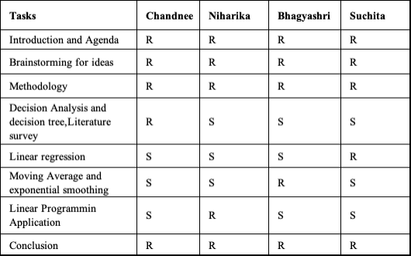

**Table 2: Literature Research Comparison**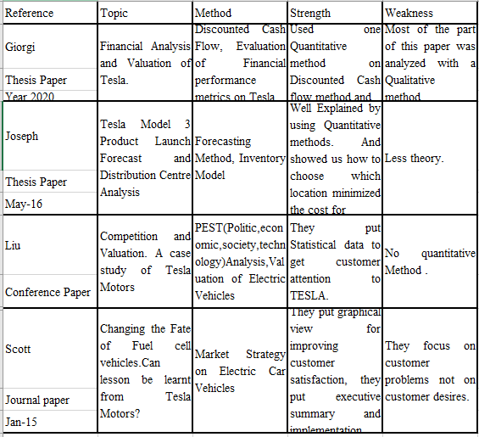

# **Quantitative Analysis**

## Decision Analysis on different Tesla Electric Vehicles

Tesla’s electric motors are superior compared to the company’s competitors. In our project we choose decision analysis to evaluate which electric car of tesla gives maximum expected monetary value. We make a decision table with the condition 3 states of nature like High demand, medium demand, Low demand with a probability of .33 for each state. Then we choose three alternatives of Tesla, Full and mild hybrids, Plug-in-hybrids, and battery electric hybrids. The payoff values are profits generated considering multiple criteria like customer requirement, gasoline savings cost, Car mileage cost and maintenance cost. The aim is to maximize profits and minimize loss. After putting their demand on QM software decision, we get the maximum EMV $45800 for Full -mild hybrid electric car.

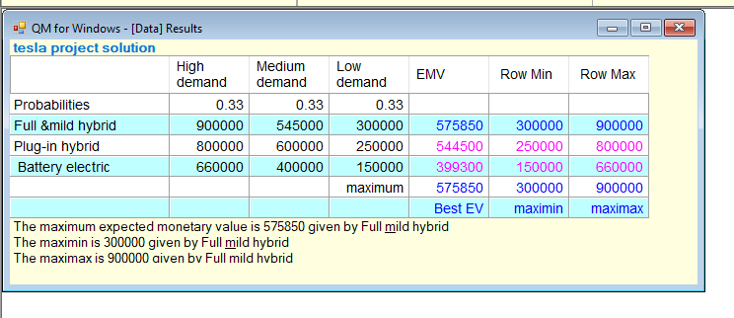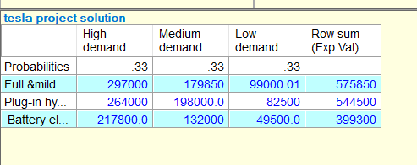

Figure 1: EMV value

Depending upon EMV value, Full and mild hybrid gives the maximum EMV value, so Tesla should produce full and mild electric vehicles more than others.

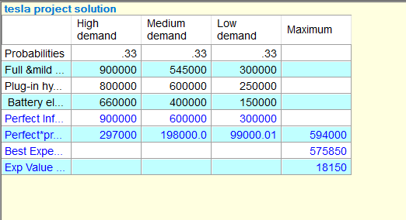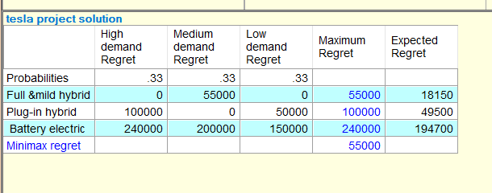

Figure 2: EOL Value

Tesla sometimes third parties sell their product to customers which charges $60,000 for providing their service. However maximum info for perfect should be paid by QM results is EVPI= 594000-575850=$18150. So, Tesla should not spend more than $18150 for perfect information based upon decision analysis. Based on EOL or opportunity loss table, Full and hybrid give minimum value.

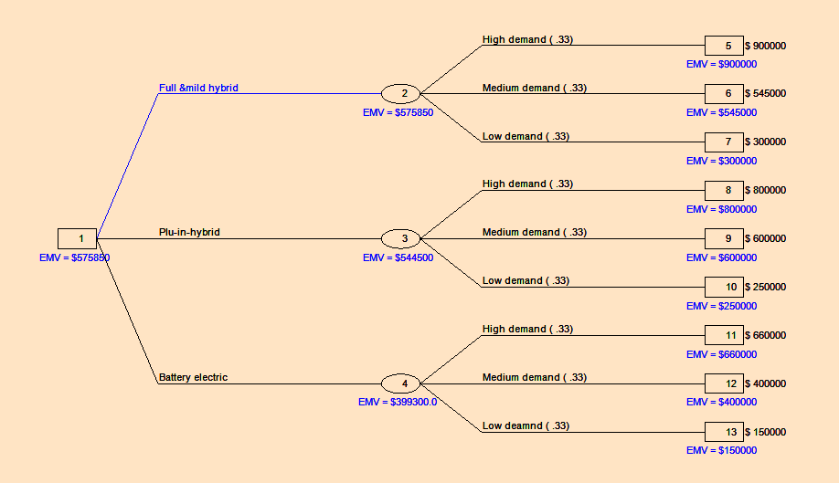Figure 3: Decision Tree Analysis

**Finally, using the decision tree we find the best alternative option among others based on maximum EMV value.**

## Forecasting using Quantitative Methods

The quantitative forecast method uses past data to forecast future data especially with numerical data and continuous pattern. This method is generally used for short term predictions. It is based on mathematical models and objective in nature. The forecast information and technique must match the intended application.

* For strategic decisions such as capacity or market expansion highly aggregated estimates of general trends are necessary
* Sales and operations planning activities require more detailed forecasts in terms of product families and time periods
* Master production scheduling and control demand highly detailed forecasts, which only need to cover a short period of time

In this project we use three quantitative methods:

* Regression analysis.
* Moving Average
* Exponential smoothing

### Regression Model

Regression analysis is a very useful technique for today's management. Regression has been used to analyze and forecast demand for new products. The main objective to use this model is to understand the relationship between two variables one is dependent (response) and known and other is independent (explanatory )and unknown and has interest in. The second objective is to predict the dependent variable based on the independent variable. Where the estimated form of the equation is as follows,

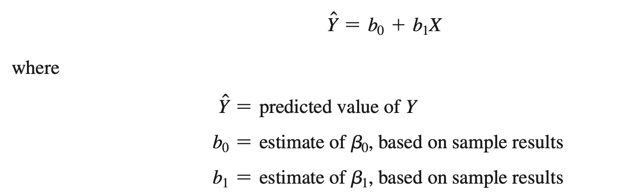

Figure 4: Linear Regression

**Q. Problem statement:** Production team of Tesla feels that demand for S3 cars can be related to the years, develop the regression model that could be used to predict the demand for year 2022 and check if demand will increase in upcoming years and depend on year? Using the data, test to see if there is a statistically significant relationship between demand and the years.

Tesla’s regression model is shown below,

Y cap = -40958.4286+46110.4286 *X,

we can use this equation to forecast the related demand for future years by putting their values as a X in the above equation. Next period forecast for period 8 is 327924.571, This means that in the year 2022 the demand for S3 tesla cars is predicted to be 327924. 571. Demand has positive linear relationship with years.

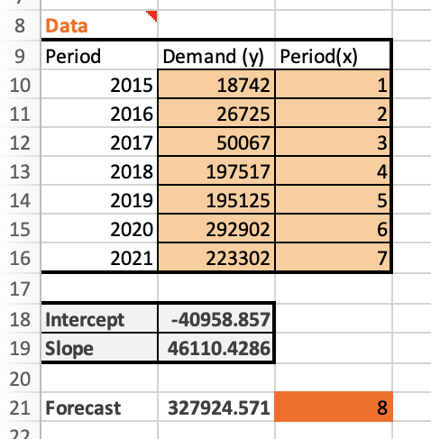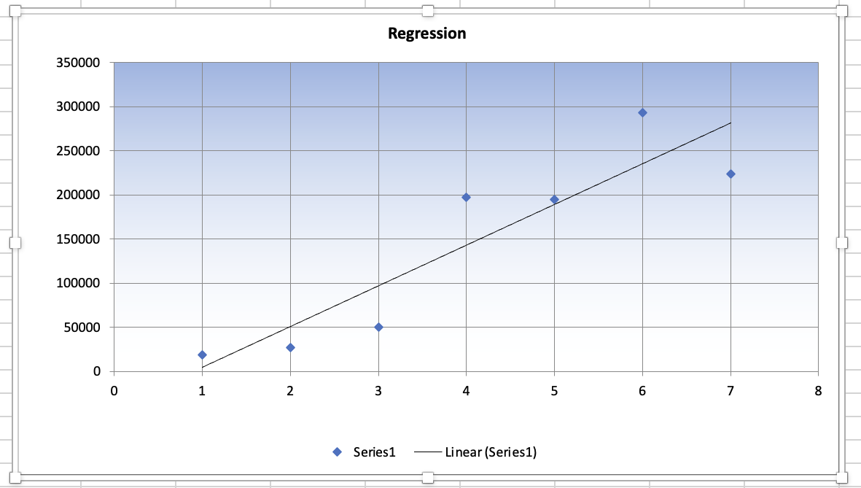

Figure 5: Linear Regression Calculations

**Usability of the model**

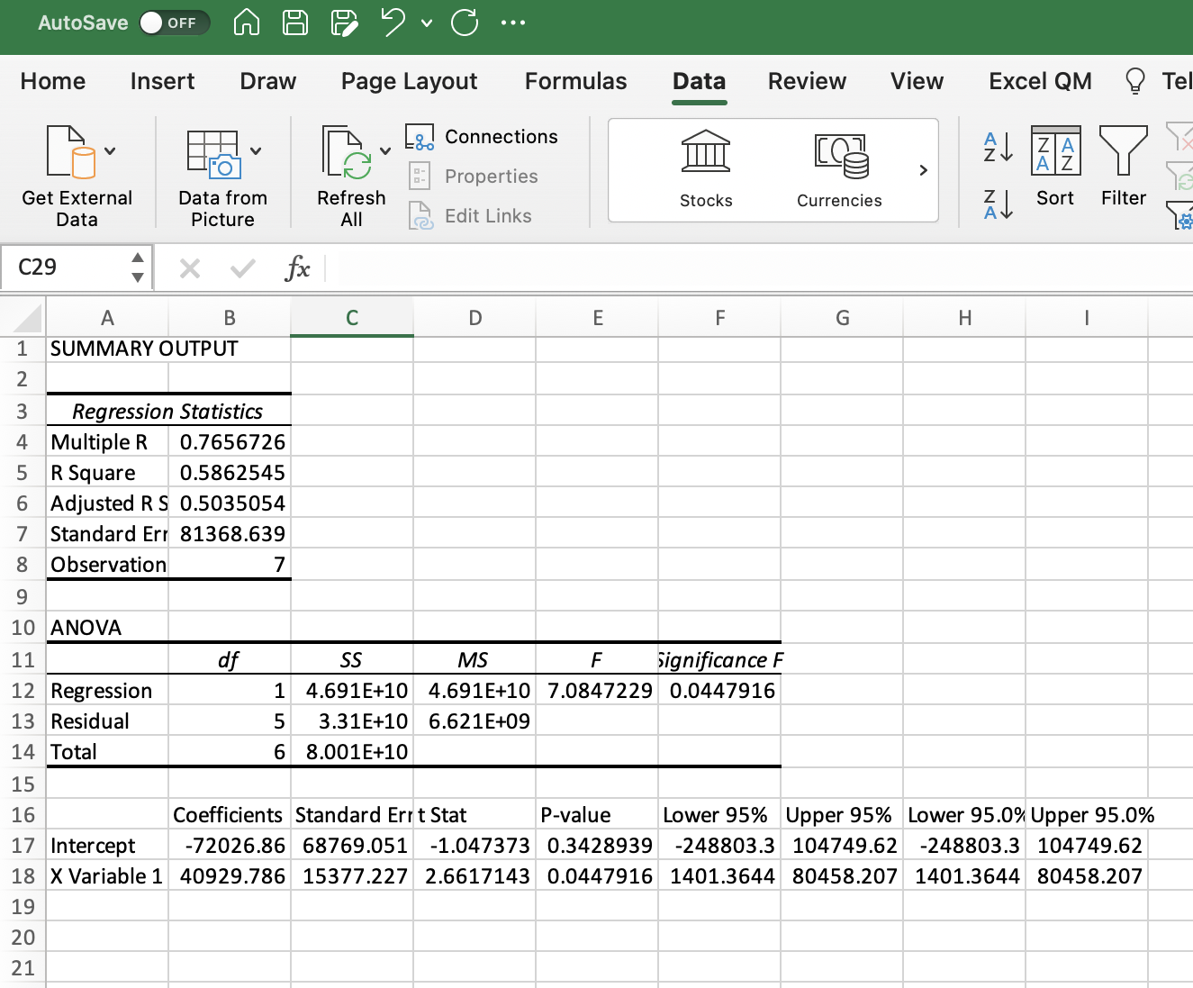

Figure 6: Linear Regression Calculations

To test the significance of the model. We assume that the errors are independent, normally distributed with the zero mean and have a constant variance.

**Coefficient of determination**: Coefficient of determination also known as a R square answer, how much of the data does this model explain? This value must be in the range of 0 to 1. In the case of tesla, the R square value is 0.5862, this means that more than half of the data is explained by this model. 58.62% of variability in the data is explained by the regression model.

**Coefficient of correlation**: Coefficient of correlation also known as a r expresses the degree of strength of linear relationship between 2 variables. It is square root of determination coefficient, and it should be between - 1 to + 1. It is positive when slope of the line is positive in Tesla’s case r=0.76566 and it shows the slope of the line is positive.

**P- values:** We test the coefficients by calculating the T-statistics and then P -values. P- value for X is 0.04479 which is less than the alpha 0.05 and we can say that the coefficient is acceptable, and we can reject the null hypothesis.

**F-statistics:** This model has F- statistics 7.084 and the significance if it is 0.0447. If we consider an alpha 0.05 then the significance of f value is less than 0.05 which means this model is acceptable. If we test the same model for alpha 0.10 then also, we can reject the null hypothesis and say this model is acceptable.

**MAD**: In the analysis we have performed, the MAD value from regression analysis is 37244.1633, which is less than the rest of the forecasting models which states that the linear regression model is good to analyze the results and has less spread out from the mean.

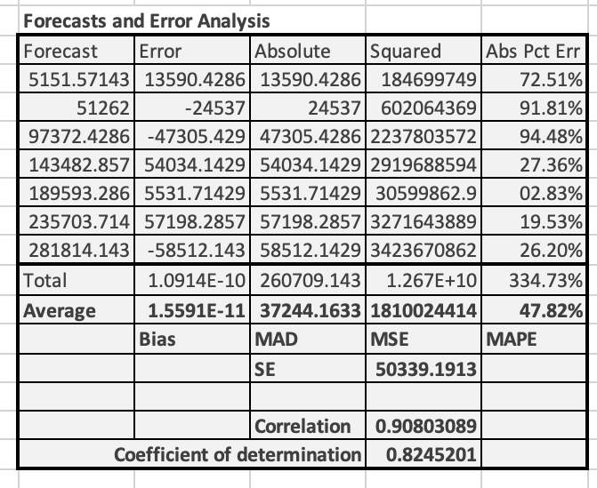

Figure 7: Linear Regression calculations

### Moving Average

A moving average is **a calculation used to analyze data points by creating a series of averages of different subsets of the full data set**. By calculating the moving average, the impacts of random, short-term fluctuations on the price of a stock over a specified time frame are mitigated.

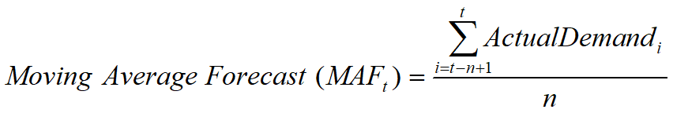

Figure 8: Moving Average

Based on raw data sales of tesla from year 2015-2021 calculation are made as follows

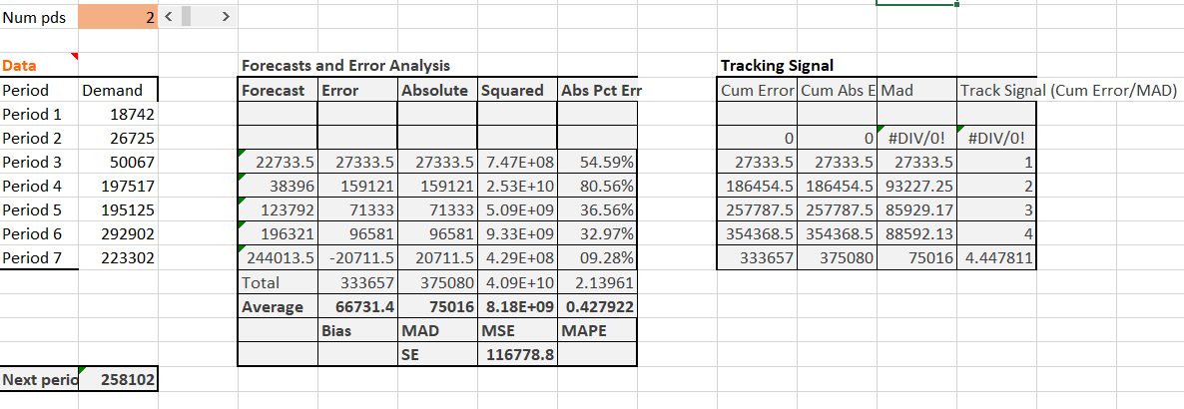

Figure 9: Moving Average-By Excel

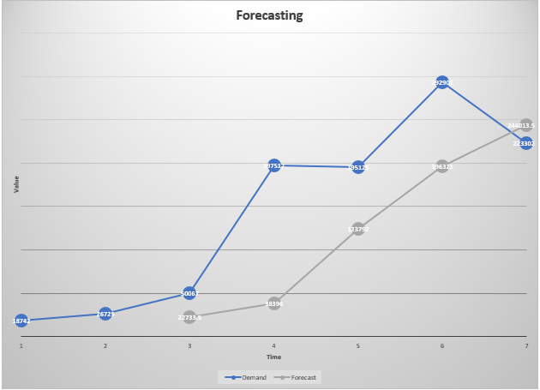

Figure 10: Moving Average- Graph by Excel

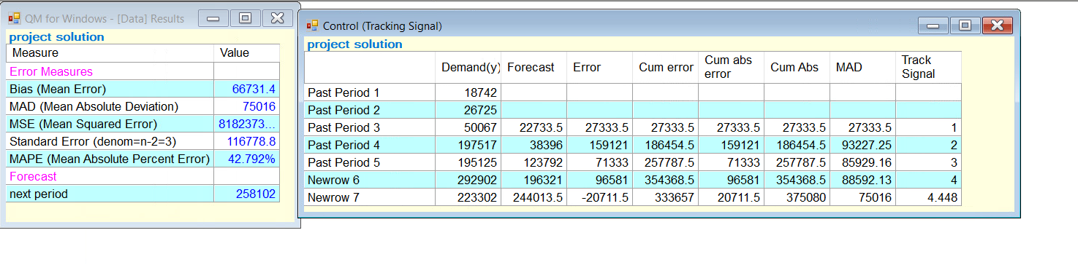

Figure 11: Moving Average by QM

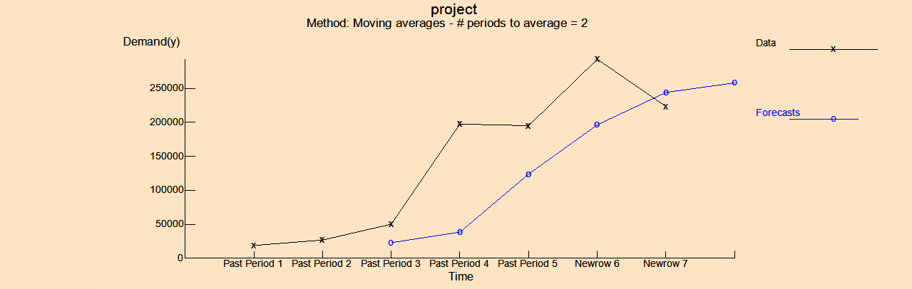

Figure 12: Moving Average- Graph By QM

After applying the moving average on Tesla sales data from 2015 to 2021, we got forecasts for next year 2022 -**258102** sales. (Using both method by excel and QM)**.** MAD for moving average is 75018.

### Exponential smoothing

*Exponential smoothing* is a type of moving average that is easy to use and requires little record keeping of data.

**New forecast = Last period’s forecast + *a* (Last period’s actual demand – Last period’s forecast).**

**Mathematically:**

**Selecting the Smoothing Constant:1)** Selecting the appropriate value for *a* is key to obtaining a good forecast.2) The objective is always to generate an accurate forecast.3) The general approach is to develop trial forecasts with different values of *a* and select a that results in the lowest *MAD.*

**Exponential smoothing - Finding Alpha Value**

Alpha value =**.94**

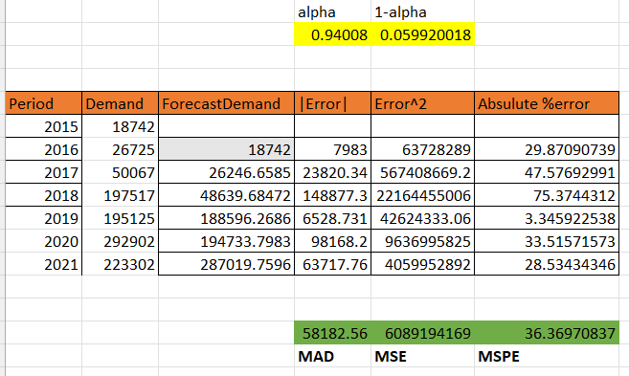

Figure 13: Finding Alpha Value

The changing in tread/ demand in sales, error occurs to smoothing the errors we need the alpha. However, after comparing alpha with MAD, MSE, MSPE we got lowest alpha =.94008. To predict better forecasting of upcoming years.

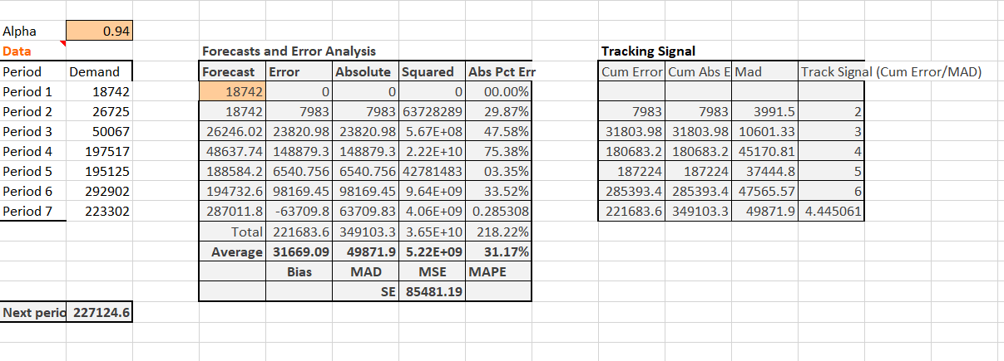

Figure 14: Exponential smoothing - By Excel

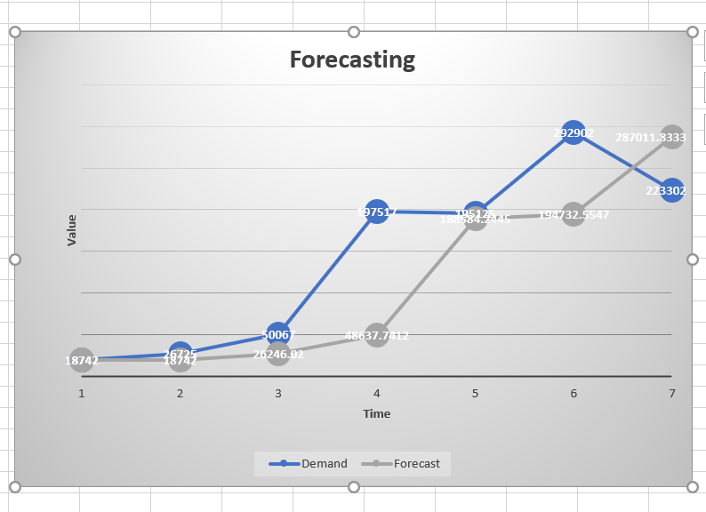

Figure 15: Exponential Smoothing-Graph by Excel.

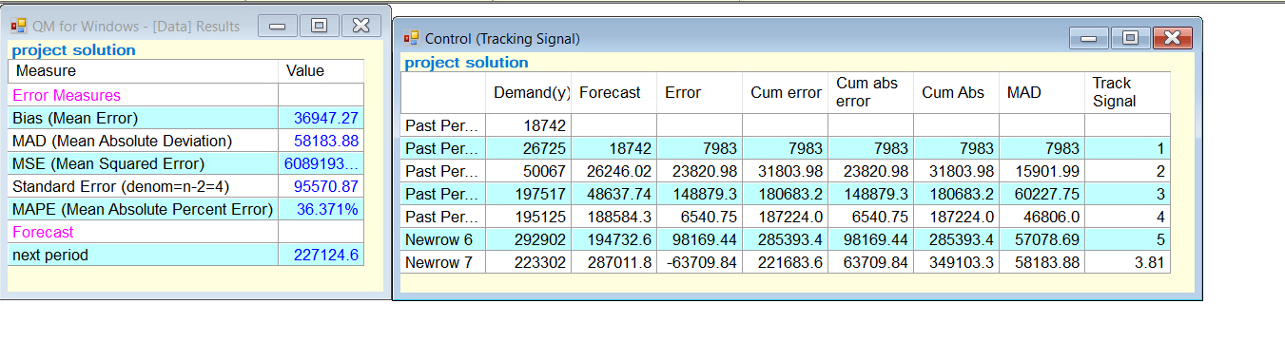

Figure 16: Exponential Smoothing-By QM

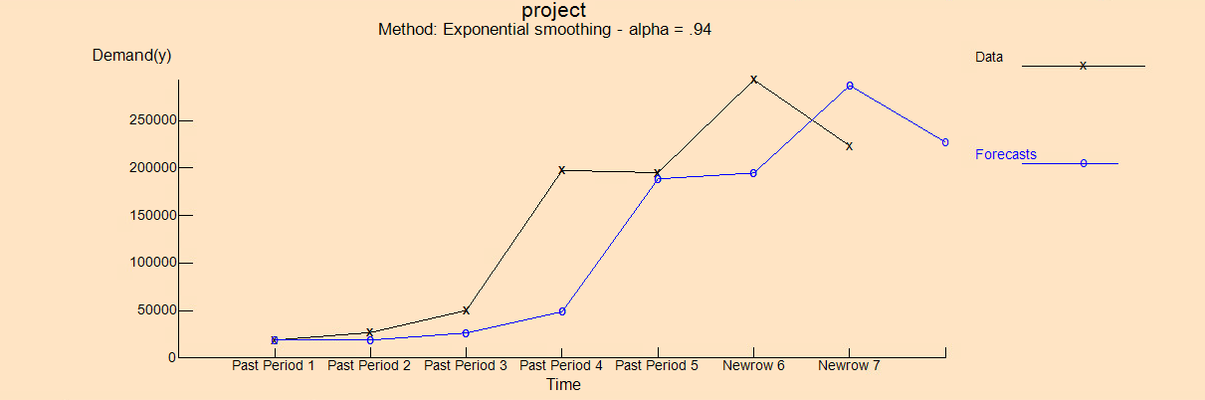

Figure 17: Exponential smoothing - Graph by QM.

After applying the moving average on Tesla sales data from 2015 to 2021, we got forecasts for next year 2022 -**227124.6** sales (using both method by excel and QM).MAD for moving average is 58183.88.

## Linear Programming Application

Linear programming establishes a plan that efficiently allocates limited resources to achieve the desired objective. The linear programming problems aim to find the most, or least, of some quantity. Often profit or expenses. Steps in Linear Programming include:

1) Understand the problem.

2) Identify the objective and the constraints.

3) Define decision variables.

4) Use the decision variables to write mathematical expressions for the objective function and constraints.

The following problem is the most common Linear Programming application- Product Mix problem. Product mix problems use LP to decide how much of each product to make given a series of resource restrictions.

**Problem**: Tesla Motors produces two types of electric cars, the *Model S* and the *Model X*. The *Model S* is sold for $70,000 and the *Model X* is sold for $120,000. Raw materials for the *Model S* cost $40,000 per unit and for the *Model X* cost $35,000 per unit. Only 60 *Model S* can be produced per week. The weekly demand of *Model X* is 300 units. There are W, X, Y and Z types of resources used in the manufacturing of electric cars. Each of these resources are available to operate for 1800, 2400, 1500, 1000 min/week respectively. *Model S* uses Resource W for 16min, Resource X for 16 min, Resource Y for 18 min, resource Z for 8min.*Model S* uses Resource W for 16min, Resource X for 16 min, Resource Y for 18 min, resource Z for 8min. *Model X* uses Resource W for 11 min, Resource X for 32 min, Resource Y for 7 min, resource Z for 6 min and all the enterprise’s costs and expenses - except for those associated with raw materials - amount to $5,000,000/week. How many *Model S* and *Model X* should Tesla produce so that the enterprise’s profit is maximized?

**Solution**: In formulating this problem, the objective is to maximize profit. There are 4 constraints indicating the available resources, 1 constraint each indicating maximum production for model S and demands for model X. The variables are defined as:

S = number of units of Model S, X = number of units of Model X.

But first Tesla Motors must establish the profit per car:

1.The Model S is sold for $70,000. The raw material for the car costs $40,000. The profit per Model S $70,000 - $40,000 = $30,000.

2.The Model X is sold for $120,000. The raw material for the car costs $35,000. The profit per Model X $120,000 - $35,000 = $85,000.

The objective function may now be stated as:

**Maximize Profit**: 30000S + 85000X

**Subject to**: 16S + 11X <= 1800……………… (Resource W)

16S + 32X <= 2400……………… (Resource X)

18S + 7X <=1500…………….… (Resource Y)

8S + 6X <= 1000………………... (Resource Z)

S = 60……………………….…… (Model S Production)

X <= 300………………………… (Model X Demand)

Solving in QM software,

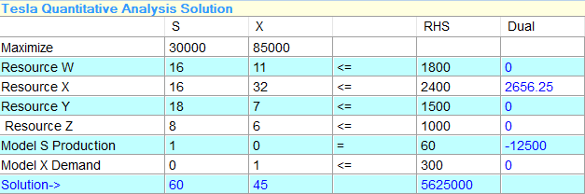

Figure 18: Linear Programming Solution

The optimum solution is 60 units of Model S and 45 Units Model X for maximum profit.

Net Profit = Optimum Solution – Weekly enterprise’s expenses and cost

Net Profit = $5,625,000 - $5,000,000 = $625,000.

**Sensitivity Analysis:**

As there is always some uncertainty in the input data, it is useful to know the range and under what conditions the components of a particular solution remain the same. The sensitivity of a solution to changes in the data gives us insight into possible technological improvements in the process being modeled.

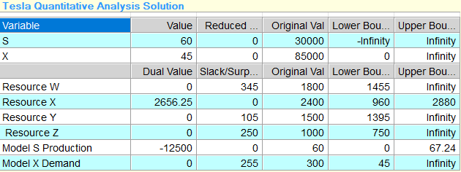

Figure 19: LP Sensitivity analysis

The profit on Model S is $30000, which is indicated as the original value in the output. The profit on Model S has a lower bound of negative infinity (it may decrease by any amount) and an upper bound of infinity (it may increase by any amount). This means that there is only one optimum solution. The profit on Model X has an upper bound of infinity and lower bound of $0. The current optimal solution will stay the same in this range.

At the optimum solution (60,45) the resource X and Model S production are binding constraints. If additional units of resource X and model S production are made available, then profits will increase. Resource W, Resource Y, Resource Z, Model X demand are non-binding constraints as there are extra units available that are not being used. For a nonbinding constraint, obtaining additional units of that resource will not result in higher profits and will only increase the slack.

**Graphical Solution**: The graphical solution works well with two decision variables. It provides valuable insight on how larger problems are structured. The following image is a graphical solution for Tesla Motors’ product mix problem.

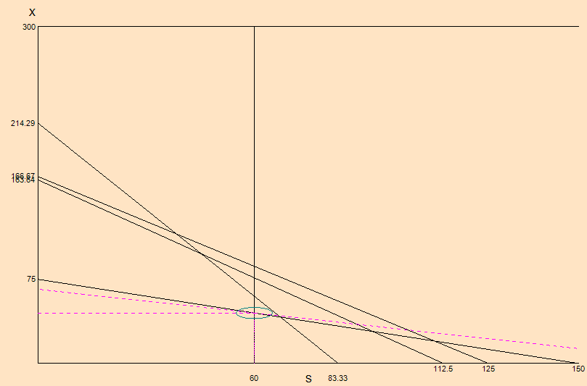

Figure 20: LP Graphical Solution

The above graphical solution is (60,45). For maximum profit, 60 Model S and 45 Model X need to be produced.

# **Conclusion**

* From the Decision tree we can say that Tesla should produce Full and mild hybrid cars based on its Max EMV value to minimize loss among others.
* Linear regression model shows that demand and year have positive linear relationship and when year increases demand increases. The acceptance test of this model says that the significance of f is less than the alpha 0.05 and we can reject the null hypothesis and accept the model. The p-value of coefficient is less than alpha, and it is a good value. More than half of the data is being used to determine this result says r square value.
* With quantitative techniques used in our project we can conclude that they can be used for optimizing production of electric cars, accurate forecasting of sales and decision analysis.

# **References**

1. Tesla Inc. (n.d.). [*Tesla: Electric Cars, Solar & Clean Energy*](https://www.tesla.com/). <https://www.tesla.com/>
2. Render, B., Stair Jr, R. M., Hanna, M. & Hale, T. (2018). *Quantitative Analysis for Management*. Pearson.13th Edition.
3. Massachusetts Institute of Technology. (n.d.). *Steps to Linear Programming.* <http://www.mit.edu/~hlb/MATH318/linearprogrammingsteps.html>
4. Massachusetts Institute of Technology. (n.d.). *Sensitivity Analysis.* <http://web.mit.edu/15.053/www/AMP-Chapter-03.pdf>
5. *Tesla-model-3-forecasting-and-supply-planning-66326004*. (2021, 12 05). Retrieved from https://www.slideshare.net: https://www.slideshare.net/abhinayreddygudimetl/tesla-model-3-forecasting-and-supply-planning-66326004
6. Scott Hardman, E. S.-W. (2015). Changing the fate of Fuel Cell Vehicles: Can lessons be learnt from Tesla Motors? *International Journal of Hydrogen Energy, 40*(4), 1625-1638.
7. Liu, S. (2021). Competition and Valuation: A Case Study of Tesla Motors. *IOP Conference Series. Earth and Environmental Science, 692*(2). http://dx.doi.org/10.1088/1755-1315/692/2/022103